17.107: a) The possible final states are in ice-water mix at 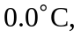a water-steam mix at 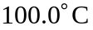 or water at an intermediate temperature. Due to the large latent heat of vaporization, it is reasonable to make an initial guess that the final state is at 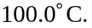To check this, the energy lost by the steam if all of it were to condense would be The energy required to melt the ice and heat it to and the energy required to heat the origianl water to 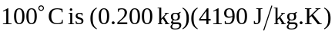 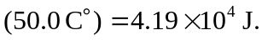 Thus, some of the steam will condense, and the final state of the system wil be a water-steam mixture at

b) All of the ice is converted to water, so it adds 0.150 kg to the mass of water. Some of the steam condenses giving up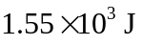of energy to melt the ice and raise the temperature. Thus, 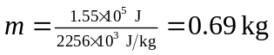and the final mass of steam is 0.026 kg, and of the water,

c) Due to the much larger quantity of ice, a reasonable initial guess is an ice-water mix at 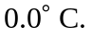 The energy required to melt all of the ice would be 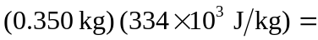 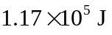. The maximum energy that could be transferred to the ice would be if all of the steam would condense and cool to 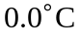 and if all of the water would cool to 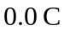,
+
This is insufficient to melt all of the ice, so the final state of the system is an ice-water mixture at 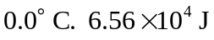of energy goes into melting the ice. So, 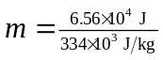 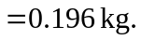 So there is 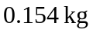of ice, and 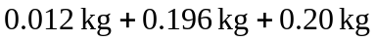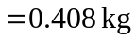of water.

